Parties to a Matter: Connecting to the OPSGuest Wi-Fi Service Using Personal Devices
OPSGuest Wi-Fi has been installed in the courthouse to provide “Parties to a Matter” with access to the Internet in certain areas throughout the courthouse.
This service requires authentication via a “Guest Account” with a specific username and password. Users must apply for a six-month “Guest Account” before accessing the service. The “OPSGuest Account Application” form is attached to this document. Guest accounts expire six months after activation, and upon expiry of the Guest account, applicants are required to re-apply for new accounts.
Users should only access the service using a single personal device.

Applying for a six-month account
- Complete the “Ontario Public Service Guest (OPSGuest) Wi-Fi Account Application for Parties to a Matter” form.
- Email the completed form to wifi@ontario.ca.
A username and password will be emailed to the applicant once the form is processed.

Connecting to the OPSGuest Wi-Fi using the Guest Account
- After you have received your username and password, search for available Wi-Fi signals within the courthouse, select OPSGuest, then click Connect.
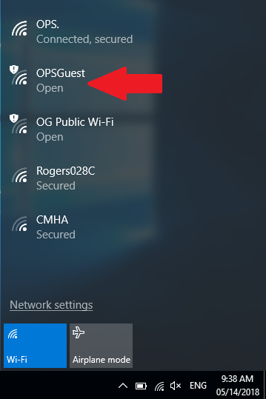

- Open the web browser on your device and attempt to browse the Internet. You will be presented with the “Welcome to Government of Ontario Guest Wi-Fi Service” web page. Click Sign in.
Do not register to access the network by completing the form on the “Welcome” page. This will only provide you with temporary, 8-hour access to the service.
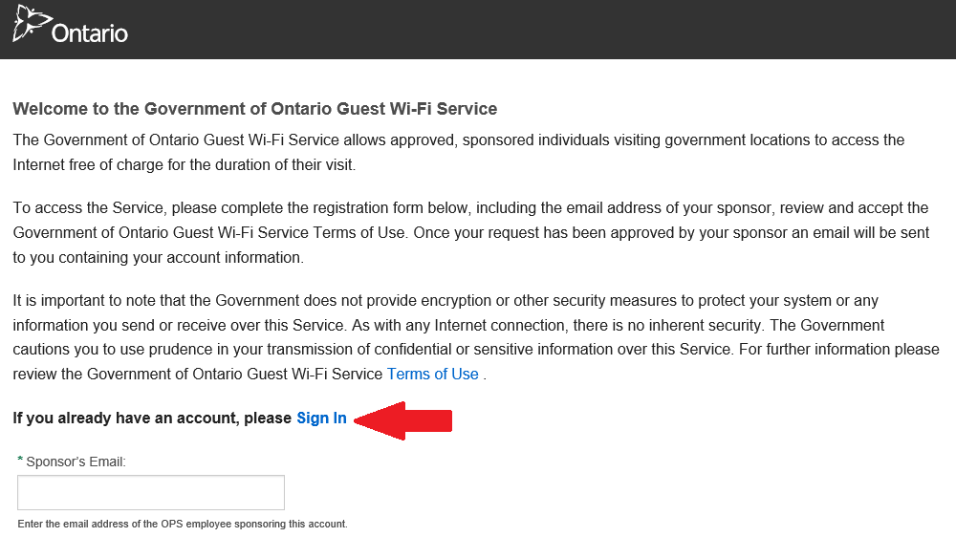
- You will be taken to the Login page. Enter the “Guest Account” username and password that was sent to you, then click Log In.
- It might take up to 30 seconds to establish the connection. Once connected, you should see the screen below. You are now connected to the OPSGuest Wi-Fi.
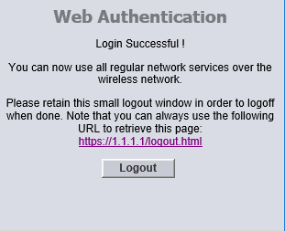

Dealing with connection issues
OPSGuest Wi-Fi is provided as a convenience only. No support is offered for this service.
Please note that Wi-Fi should not be relied upon to present a case.

